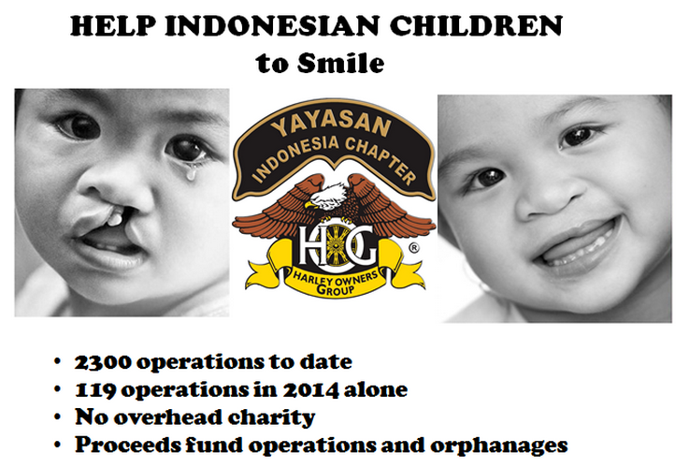A reminder that the HOGS/Hotel Kristal event takes place this Friday at Jagorawi Old Course. Fantastic day and lots of great prizes - but most importantly the event benefits the Tee Set’s favourite charity, the HOG Yayasan, a charity transforming the lives of young Indonesian kids afflicted with cleft lip and palate.
If you haven’t signed up yet then please have a look here to find out how you can – we really would love to see strong Tee Set support for the HOGS – and those kids.

