2017 Results
Results of our 2017 matches and the final Inter-League standings are below.
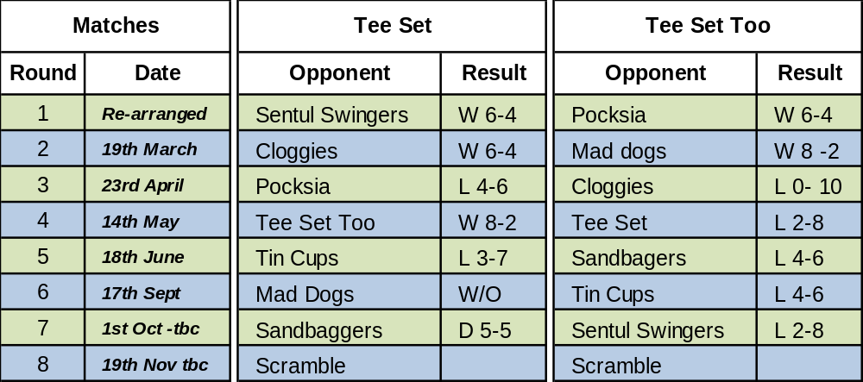
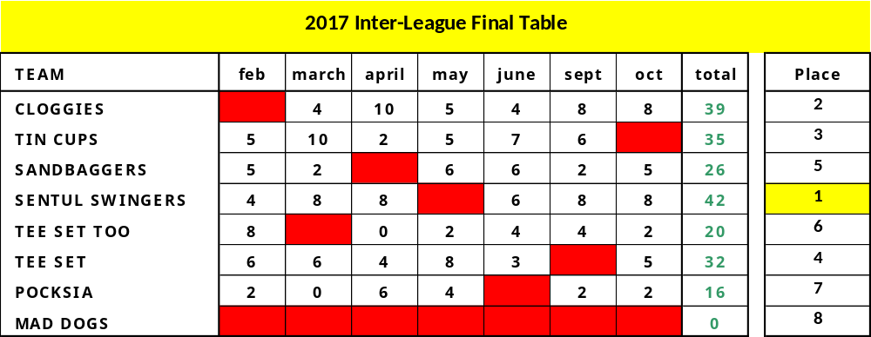
Note that with Mad Dogs being unable to field a side for all the rounds, their matches have been scratched for the purposes of the rankings. Congratulations to Sentul Swingers who are 2017 Champions succeeding Cloggies who made a valiant effort to defend the crown.
A huge thank you to all the Tee Set players who turned out to support our teams and participate in the 2017 Inter-league matches especially as we fielded 2 teams to cover the last minute drop out of Jakarta Loose Impediments so as to try and retain the integrity of the event with 8 teams. We have had some great matches, developed many new friendships and look forward to 2018 when we hope to win back the trophy.

Scramble Event and Prize Giving: November 19th

The end of season modified scramble Prize Giving and buffet were held at Jagorawi as usual and again proved to a fun and enjoyable day as the seasons Champions were awarded their Trophy and Pocksia the Wooden Spoon. However, Pocksia did have the final say on the year by winning the day with a impressive score of 117: equivalent to net birdies on almost every hole.

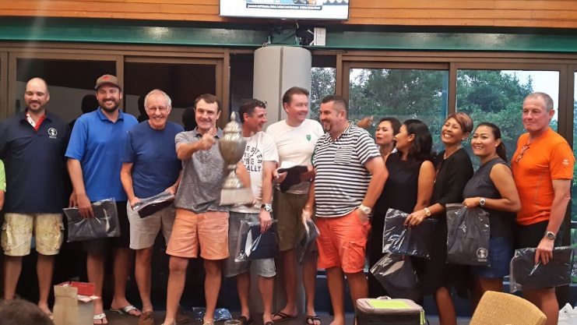



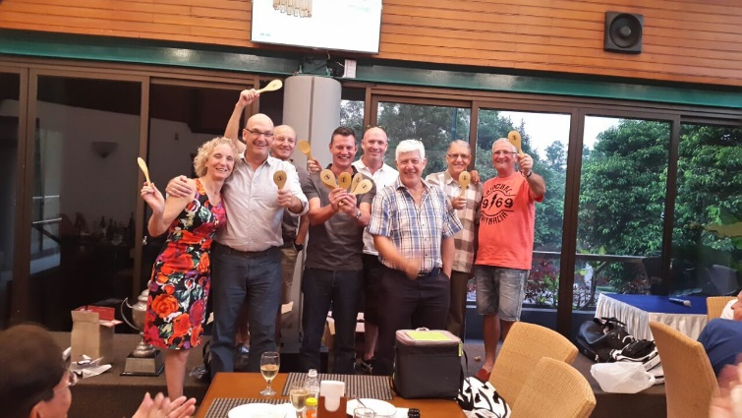

Match Reports
Round 7: 1st October
4 teams entered the round with the potential to be crowned champions but with Sentul Swingers showing the strength in depth of their team to defeat Tee Set Too 8-2 they deservedly were crowned Champions for 2017. Tee Set played Sandbaggers in what was always going to be a tight match and so it proved with the teams sharing the spoils in a 5-5 draw.
Round 6: 17th September
With Mad Dogs scratching, Tee Set Too took on league leaders Tin Cups looking for some revenge after Tee Set went down 7-3 during the summer period. A vallient effort just came up short with Tin Cups winning the final match on 18th green to secure a 6-4 victory but in not letting Tin Cups get away, the league is now well positioned for an exciting finish on 1st October as 4 teams are realistically in with a chance of winning on the last week-end.
Round 5: 13th August
With June's games being postponed Round 5 was a split round. Tee Set played Tin Cups at BSD during the holiday season and had to field a much changed side against one of the league leaders. Although there were several close games, Tin Cups prevailed 7-3 to cement their place at the head of the league after 5 rounds. Tee Set Too played their make up games against Sandbaggers at Jagorawi and with 2 games going the wrong way on the 18th hole, were beaten 4-6.
Round 4: 18th June
The Tee Set versus Tee Set Too bragging rights match was played at Rainbow Hills as we took advantage of the Ramadan traffic to visit this wonderful layout. Some closely fought games which went down to the wire but with Tee Set prevailing in 2 of the 3 matches reaching the 18th green they ran out 8-2 winners.

Round 3: 23rd April
The holiday week-end saw a much changed side playing with many players making their 2017 Inter-league debut and even a couple making their Tee Set debut as well. This perhaps contributed to our 2 teams not quite getting over the line in the closer matches and both suffered their first losses for the season. Facing a Cloggies team looking for revenge after last month's loss to Tee Set, Tee Set Too lost 0-10 and Tee Set also did not quite get over the line against Pocksia, losing 4-6.
Round 2: 19th March
A potentially tricky round saw Tee Set play 2016 champions, Cloggies, and Tee Set Too play 2016 runner's up, Mad Dogs. However, some strong play saw both teams emerge victorious with Tee Set prevailing 6-4 and Tee Set Too taking advantage of a slightly short-handed Mad Dogs to win 8-2.
Round 1: 19th February
With play initially rained off on the scheduled day, it was left to the captains to rearrange the fixtures. Tee Set Too played Pocksia on 12th March at Cengkareng winning 6-4. Tee Set's match against Sentul Swingers took 3 efforts and finally was completed on Sentul Swingers home course on 30th September where the final 3 games were tied 3-3 to add to the already completed games at Riverside for a Tee Set victory 6-4. This would prove to be the only loss inflicted on 2017 champions Sentul Swingers.

